Architecture Block Diagrams

**Web Page**

Source: web address

Server Connection

**Web Scraper**

- Using the import requests from the Python language, connect to specific hardcoded web addresses so the scraper can accurately analyze each website’s format

**-** Data received from the web scraper is saved to a CSV file for further analysis

- Each scrape will be saved to a folder designated by web address and further labeled by the date and time

**Sentiment Analysis**

- CSV file import is analyzed based on data points

- Data points will be categorized with numbers associated with their context. 1 -> negative, 2 -> neutral, 3 -> positive, 4 -> mixed

- Analyzed data is saved in CSV format to a new file

**Reports**

- Import from Sentiment Analysis CSV

- Use Matplotlib to create data charts

- Export to PDF or Word document

Data Flow/ Control Flow

Data

Control

   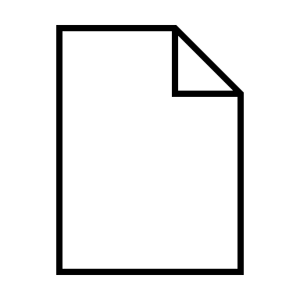

Web Page Web Scraper Sentiment Analysis Report

Languages

* Python

Third Party Libraries

* Scikit-learn
* Matplotlib

Dev Environment

* CoCalc
  + Jupyter Notebooks